49th Annual NAEN Conference
MAKING A SPLASH!
Creating Positive Labor Relations and Engaging in Successful Collective Bargaining
March 11-14, 2018 ¬─ Sheraton Sand Key, Clearwater, Florida

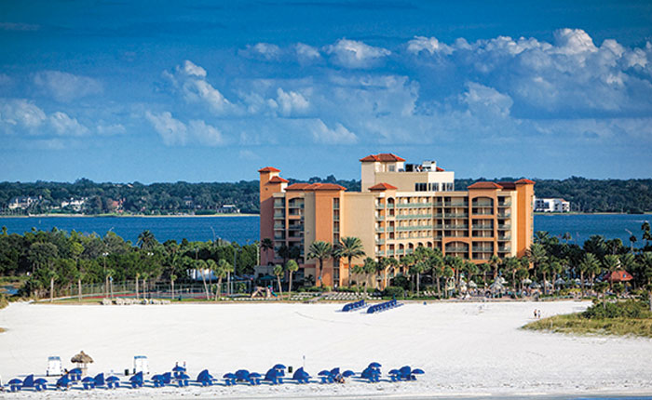
The 49th Annual Conference of the North American Association of Educational Negotiations will bring together approximately 100 educational negotitations and employee relations specialists from all over the United States and Canada to learn, participate, and network for three and one-half days of professional development in educational negotiations and employee relations. This conference offers the best opportunity to gain new insights, sharpen your negotiation skills, network with your peers, and share the best practices with your colleagues.
This conference is recommended for all education based management professions who share an interest in employee and labor relations and who are committed to professional development, including school board members, superintendents, school attorneys, negotiatiors, building administrators, Principals, pupil service personnel, HR directors, and labor specialists. If you have any questions regarding this conference, please email us execdir@naen.org. We hope you will be able to join us in Clearwater for this most informative conference for professional and personal advancement.

Receive a Certificate of Completion to assist you with your professional development requirements!
- “This was my first conference and it was excellent, great topics and speakers, networking was fantastic, learned from conference and social time.”
- “One of the very best things about this conference is the tone─ warm, friendly, focused, lots of interaction.”

MAKING A SPLASH
Creating Positive Labor Relations and Engaging in Successful Collective Bargaining

NAEN’S 49th Annual Conference ─ March 11-14, 2018

Saturday, March 10

6:00-8:00 Board Dinner

Sunday, March 11│Pre-Conference

Breakfast on your own!

9:00-3:00 a.m.

Negotiation Preparation

11:30-12:30 p.m. Lunch on your own

Or

9:00 – 11:30 a.m.

How to Conduct and Investigation

12:30-3:00 p.m.

How to Conduct and Arbitration

Conference

4:00-5:30 p.m. Keynote Speaker

Social Media and the legal restrictions using social media in the hiring process

5:30-7:00 p.m. Hospitality Dinner

Monday, March 12

7:30-8:30 a.m. Breakfast

8:30-9:45 a.m. Keynote Speaker

Interest Based Problem Solving and the Brain on Bargaining; What you don’t know about neurology can hurt you at the table

10:00-11:00 a.m.

Mental Health Initiatives in School Districts

Or

Implementation of a Provincial Wide Bargaining Agreement

11:00-11:15 a.m. Snack Break

11:15-12:15 p.m.

Negotiating like Genghis Khan

Or

When do Bargaining Unit members have a right to union representation and when do they not?

Or

Canadian Litigation & Arbitration Review

12:15-1:15 p.m. Lunch

1:15-2:15 p.m.

Last Chance Agreements

Or

Off Duty Conduct

4:00-5:30

Canadian Caucus

Tuesday, March 13

7:30-8:30 a.m. Breakfast

8:30-9:45 a.m. Keynote Speaker

Private Investigation services that
can assist School Boards

10:00-11:00 a.m.

Telemedicine in our Schools

Or

HR’s role in the Board’s Strategy Plan

11:00-11:15 a.m. Snack Break

11:15-12:15 p.m.

Staffing Teacher Proficiencies

Or

Past Practice…What does that exactly
Mean?

OR

Teacher Instructional Hours and Assigned Time; Tracking and Managing to ensure compliance and Efficient use of Human Resources

12:15-1:15 p.m. Lunch

1:15-2:15

Managing your Board during Negotiations

Contract Language

4:00-6:00 p.m. Dinner Reception

Wednesday, March 14

7:30-8:30 a.m. Breakfast

8:30-8:45 a.m. Keynote Speaker

Negotiations – Communications and the Media

10:00-11:30 a.m.

Canadian Affairs

US Affairs

12:00-2:00 p.m. Board of Directors Meeting

MAKING A SPLASH
MARCH 11-14, 2018 │CLEARWATER BEACH, FLORIDA

Collective
Bargaining with
NAEN Experts!

Join us for the pre-conference on
Sunday, March 11th for this unique
opportunity!

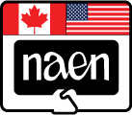

Send your entire bargaining team and you will walk away from a full day session with ground rules, draft proposals, salary analysis, health insurance analysis, negotiation strategies, and be well on your way to a successful negotiation process!

Your entire team will be paired up with a team of NAEN experts from the field who will work with your team to create specific proposals based on your unique bargaining circumstances. Let us help get you well on your way for successful collective bargaining in your District!

Join us Sunday, March 11th 2018 during the pre-conference. The cost for your entire team (as many people as you would like to send) is only $995.00 for the full day ($1,195 for non-members). This is not per person! It is for the entire team!

Take advantage of this opportunity! The number of teams available to participate is limited, so sign up fast!

REGISTRATION
 |  |  | Member | Non-Member |  | Total
Full Conference Registration |  |  | $550.00 | $675.00
One Day Registration |  |  | $305.00 | $320.00
OPTIONAL EVENTS
Training Elective- Sunday, March 11
Full Day Session for
entire bargaining team: |  |  | $995.00 | $1,195.00
Half Day Sessions (am or pm or both)

Each session is $125.00 or both for $200.00

Purchase Order Number: _____________________
Bill District/ Organization □
Check Enclosed □
Please make checks payable in U.S. funds.

NAEN'S FEIN Number: 59-2112656

NAEN accepts American credit cards - PaySchools Online and PayPal
See our webpage for processing directions.

Attendee
Name:
Title:
District/Organization:
Address:
City/State/Province/Zip
Phone/Cell
Email:
Is this your first NAEN conference? Yes □ No □
If you have food allergies or dietary requests or require special services or accommodations, please describe:

